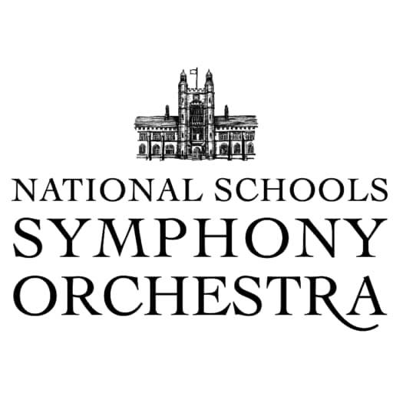

INFORMATION ABOUT APPLYING FOR ASSISTANCE WITH FEES

A small number of means-tested bursaries are available, covering up to a maximum of 50% of the course fee. Please note that the decision whether or not to award a bursary, and the value of any bursary awarded, is entirely at the discretion of NSSO and Malvern College.
It is helpful to us if, in the first place, you seek support from elsewhere. In particular from your own school or LEA; they often have funds reserved to meet such need. In addition there are many quite localised charities across the UK which support arts-based activities for young people from that area. Google often turns up surprisingly little known trust funds with just this aim in mind!
The Harrison Memorial Fund, administered by the IAPS, awards grants to young people aged 8 – 14 who need financial support to attend residential music courses in the UK. Applications to this fund enjoy a high level of success but awards are generally modest. Click here to download an application form or further information, please email Kathy Uttley: iapsitrustmusic@gmail.com
Organisations such as Awards for Young Musicians make grants to talented instrumentalists and you can find out more at www.a-y-m.org Other useful websites include www.helpmusicians.org.uk which features a “funding wizard” and www.futuretalent.org along with www.christinebrowntrust.org.uk .

How we award bursaries
Our bursaries are awarded on a sliding scale based on the household’s total net income (defined as total annual income less total annual expenditure). If your combined household take-home employment-related pay exceeds £30,000 you are not likely to receive an award. The maximum award that is normally given is 50% of the course fee. However, in exceptional circumstances it may be possible to provide a higher award.
All applications for Bursary assistance should be submitted by 31st December 2022 accompanied by the application form for the course itself and the deposit fee, if they have not already been submitted. We will inform you by mid January if your application for bursary support has been successful and the balance of the fees payable will be due by 1st February 2023. All fees must be paid prior to the start of the course.
Bursary applications are dealt with by Malvern College and those conducting auditions do not know who is a bursary applicant. Offers of a place in NSSO are based on purely musical criteria and are not affected by bursary applications.

NSSO APPLICATION FORM FOR ASSISTANCE WITH FEES

Please complete ALL sections and return by 31st December to : NSSO, Malvern College, College Road, Malvern WR14 3DF or email to hello@nsso.org

Child’s name:
Instrument:

PARENTS/GUARDIAN DETAILS

Father/stepfather/guardian | Mother/stepmother/guardian
Name: | Name:
Address: | Address:
Post code: | Post code:
Post code: | Post code:
Email:
For all correspondence relating to this application.

OTHER DEPENDENT CHILDREN

Name: | Age:
Name: | Age:
Name: | Age:

Please complete the above details, together with all parts of the financial information sheet. Sign and return them by 31st December, together with any additional information/supporting evidence to:

NSSO, Malvern College, College Road, Malvern WR14 3DF or email to hello@nsso.org
The information will be treated in the strictest confidence. We are sorry if you find the form intrusive; we are sure you will recognise that it is important for us to understand the financial circumstances of the applicant’s family in deciding the level of assistance which may be awarded. NSSO has limited bursary funds but will offer financial assistance where possible to needy families.

FINANCIAL INFORMATION TO SUPPORT APPLICATION FOR ASSISTANCE WITH FEES

Information given on this form will be treated in strictest confidence.
Applicant’s name:

ESTIMATED INCOME & EXPENDITURE – year to 1 April 2022

INCOME  See notes below of income to be included. | Parent 1  £ | Parent 2  £
Employment-related earnings (net of income tax)
State benefits (child benefit, housing support, disability/career’s allowance etc.)
Other recurring income
Father/mother income totals | (i) | (ii)
Total annual income (Father and Mother)  (i) + (ii) | A £

EXPENDITURE  See notes below of expenditure to be included. | Parent 1  £ | Parent 2  £
Annual Rent or Mortgage payments
Annual Household Bills (utilities, food, council tax, etc.)
Other recurring expenditure (annual amount)
Father/mother expenditure total | (iii) | (iv)
Total annual expenditure (Father and Mother)  (iii) + (iv) | B £

TOTAL NET HOUSEHOLD INCOME

Total annual income less your total annual expenditure | A - B | £

Please note that we require documentary evidence to substantiate your income figures: e.g. a copy of a P60, P45, a statement of benefits, tax return or any other document to support an entry above.

To the best of my knowledge this is a true and accurate statement of our financial position and I undertake to report immediately any material changes to the financial position detailed.

Signature: | Date:

A FINAL NOTE
NSSO works hard to support players whose parents need help to meet the course fee. Musical talent is the only real test for joining one of the NSSO orchestras. Finance must not be a defining factor in deciding to apply. Our modest bursary fund faces increasing pressure each year but we promise to do our best to help and to take into account any exceptional circumstances.

